# ETL Project

At the end of the week, your team will submit a Final Report that describes the following:

* Extract: your original data sources and how the data was formatted (CSV, JSON, MySQL, etc).
* Transform: what data cleaning or transformation was required.
* Load: the final database, tables/collections, and why this was chosen.

Please upload the report to Github and submit a link to Bootcampspot.

## Extract

* The sources of data that you will extract from:

# **Google**

1. Kaggle: https://www.kaggle.com/petersunga/google-amazon-facebook-employee-reviews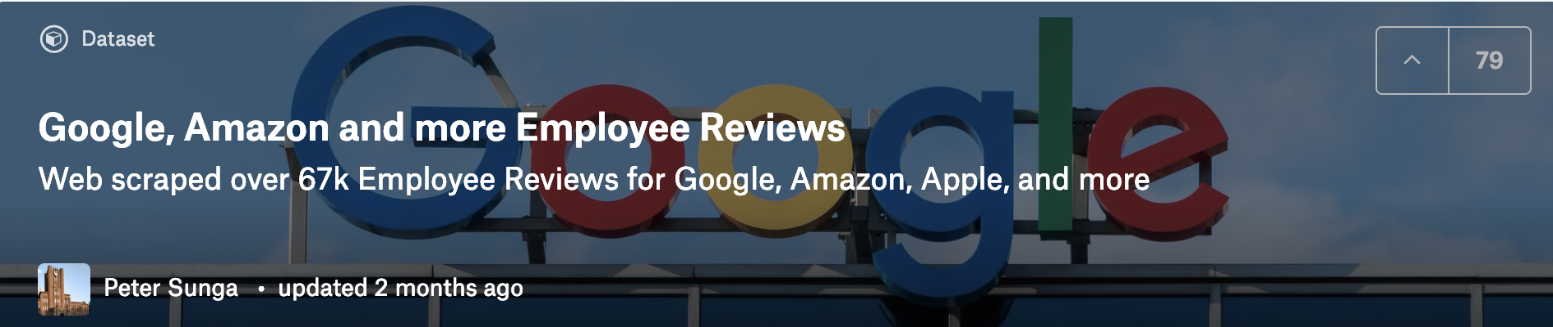

* Data format: CSV

## Transform

1. Selected only those needed columns;





1. Filter data to only selected rows:



1. Clean coloum data to remove un-wanted values (‘Current Employee – ‘ and ‘Former Employee – ‘):

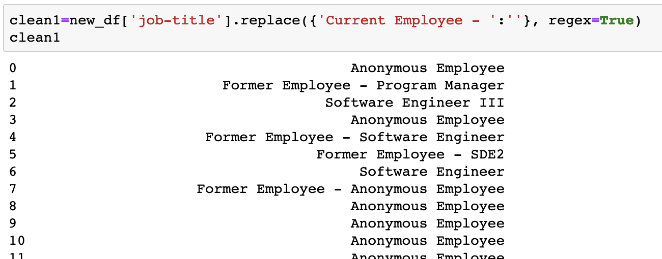

1. Remove rows associated with “Anonymous Employee” under ‘job-title’



1. Drop ‘NA’ values

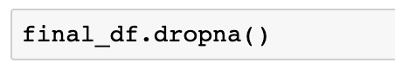

1. Get final data